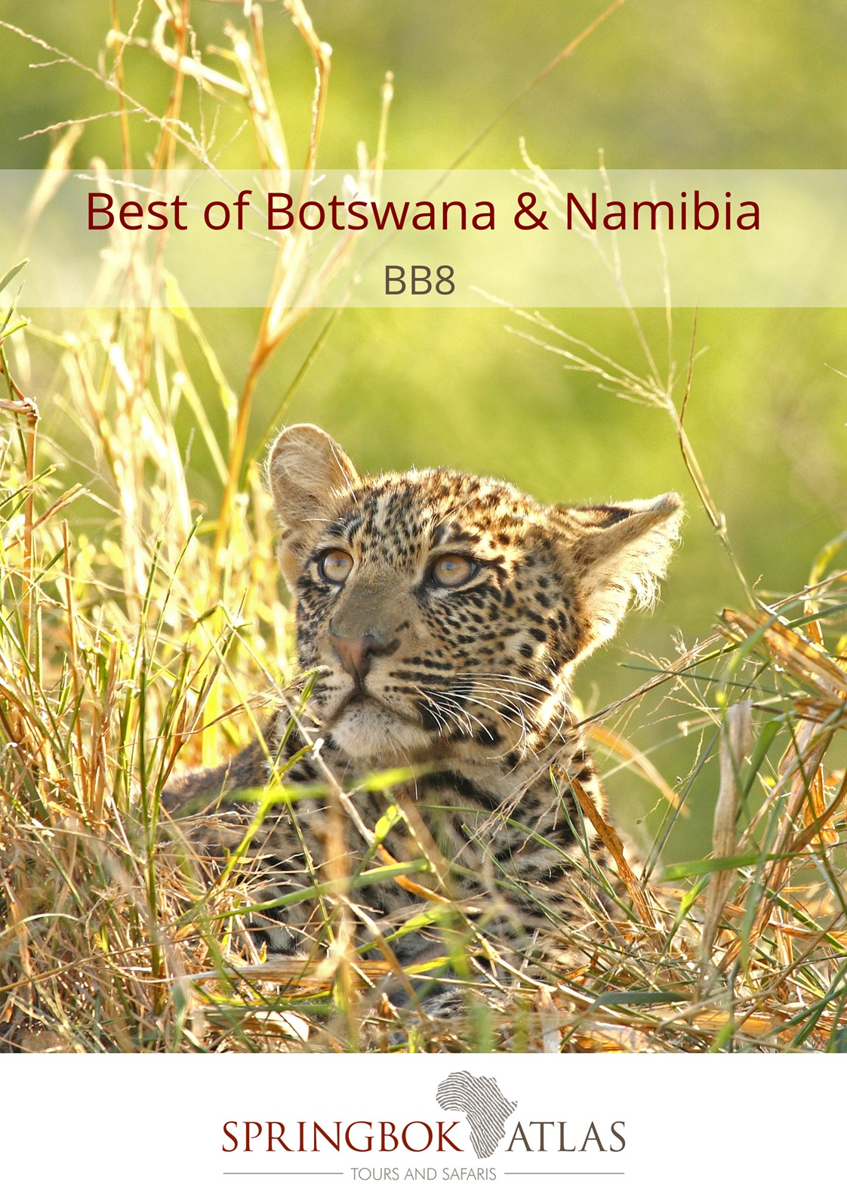

ITINERARY AT A GLANCE
DATE | ROUTING
DAY 1 | MAUN – OKAVANGO DELTA, BOTSWANA
DAY 2 | OKAVANGO DELTA, BOTSWANA
DAY 3 | OKAVANGO DELTA, BOTSWANA – MAHANGO GAME PARK, NAMIBIA
DAY 4 | MAHANGO GAME PARK – ZAMBEZI REGION, NAMIBIA
DAY 5 | ZAMBEZI REGION, NAMIBIA
DAY 6 | ZAMBEZI REGION, NAMIBIA – CHOBE, BOTSWANA
DAY 7 | CHOBE, BOTSWANA
DAY 8 | CHOBE - KASANE, BOTSWANA
 | END OF TOUR

Meal Key

BB Bed and Breakfast
DBB Dinner, Bed and Breakfast
DBB+ Dinner, Bed and Breakfast plus one additional activity
DBB++ Dinner, Bed and Breakfast plus two additional activities
FB Full Board (includes 3 meals per day)
FB+ Full Board (includes 3 meals per day) plus one additional service
FB++ Full Board (includes 3 meals per day) plus two additional services
FI Fully Inclusive (includes all meals and local drinks), plus all activities

Minimum 2 guests / Maximum 16 guests

DEPARTURE DATES
 | Feb18 | Mar18 | Apr18 | May18 | Jun18 | Jul18 | Aug18 | Sep18 | Oct18 | Nov18 | Dec18
English | 12 | 11 | 9 | 14 | 12 | 14 | 8 | 10 | 15 | 12 | 15

DURATION
8 days / 7 nights

INCLUDES
7 breakfasts, 2 lunches, 7 dinners, 7 nights’ accommodation, porterage, transportation, game watching activities and sightseeing as specified

EXCLUDES
Botswana Tourism Levy, payable upon entering Botswana

NOTE –Optional add-on 2 night extension to Victoria Falls available.

RACK RATES valid 01/01/2018 – 31/03/2018 & 01/12/18-31/12/18:
USD 4 790.00 per person sharing
USD 5 040.00 per single person

RACK RATES valid 01/04/2018 – 30/06/2018 & 01/11/18-30/11/18:
USD 5 215.00 per person sharing
USD 5 470.00 per single person

RACK RATES valid 01/07/2018 – 31/10/2018:
USD 5 415.00 per person sharing
USD 6 260.00 per single person

OPTIONAL VICTORIA FALLS EXTENSION (DAY 8 - 10)
RACK RATES valid 01/01/2018 – 31/12/2018:
USD 505.00 per person sharing
USD 640.00 per single person

ACCOMMODATION
Moremi Crossing or similar x 2 nights
Mahangu Safari Lodge or similar x 1 night
Camp Kwando or similar x 2 nights
Chobe Safari Lodge or similar x 2 nights

DAY 1 MAUN - OKAVANGO DELTA, BOTSWANA (UNESCORTED)
On arrival at Maun International Airport you will board a charter flight to the Okavango Delta.
Considered one of Nature's masterpieces, the Okavango Delta offers an insight into one of Africa's truly great wildernesses. Protected by the Moremi Game Reserve and numerous private wildlife concessions, the Okavango Delta is home to huge numbers of elephant, buffalo, lion, hippo, giraffe and zebra. [Lunch, Dinner]

DAY 2 OKAVANGO DELTA, BOTSWANA (UNESCORTED)
Spend a full day relaxing and enjoying this beautiful oasis that creates a haven for Africa’s most celebrated wildlife. Alternatively enjoy optional & for own account activities such as mokoro (dugout canoe) excursions, bush walks and boat cruises. [Breakfast, Lunch, Dinner]

DAY 3 OKAVANGO DELTA, BOTSWANA – MAHANGO GAME PARK, NAMIBIA
After a delicious breakfast, board a charter flight to Maun from where you will cross into Namibia, a country of big skies and dramatic scenery, home to diverse wildlife reserves and incredible bird watching. Enjoy an afternoon boat cruise on the Okavango River, in search of elephants, crocodiles, hippos and fish eagles. [Breakfast, Dinner]

DAY 4 MAHANGO GAME PARK – ZAMBEZI REGION, NAMIBIA
Enjoy a game drive along the floodplains of the Mahangu Game Park. Year round water ensures an abundance of game, however, during the dry winter months, the chances of seeing game is higher as the animals seek out the river and waterholes. Visit the Popa Falls, with its perennial rivers, magnificent indigenous woodlands, riverine forests, floodplains and reed - lined channels. The 'falls' are in fact a series of cascades created by a quartzite ledge that causes the river to split into numerous channels. [Breakfast, Dinner]

DAY 5 ZAMBEZI REGION, NAMIBIA
Savor the opportunity to explore the beauty of the Zambezi region (formerly known as the Caprivi Strip) during an early morning open vehicle game drive. Often described as Namibia's answer to Botswana's Okavango Delta, the rivers, wetlands and forests of the Zambezi region support a diverse range of animals that include several species such as hippo and buffalo. In the afternoon you will visit a Traditional Village where the villagers will demonstrate various fishing and hunting techniques, as well as their customs and traditions. [Breakfast, Dinner]

DAY 6 ZAMBEZI REGION, NAMIBIA - CHOBE, BOTSWANA
This morning you will re-enter Botswana. Natural riches and a low human population density have combined to make Botswana one of the most rewarding countries in Africa in which to experience a big game safari. Large areas of the country have been set aside for wildlife, from the large mammals to water-loving specialties and incredible birds. [Breakfast, Dinner]

DAY 7 CHOBE, BOTSWANA
Enjoy a thrilling morning open vehicle game drive in the Chobe National Park, the second largest in Botswana, known for its superb game viewing all year round, as it has one of the largest populations of game on the African continent. Join a breathtaking afternoon sunset cruise, in search of magnificent wildlife sightings. [Breakfast, Dinner]

DAY 8 CHOBE – KASANE, BOTSWANA
After breakfast, transfer from the lodge to Kasane Airport. [Breakfast]

WHY NOT EXTEND YOUR TRIP TO INCLUDE THE MAGNIFICENT VICTORIA FALLS (DAY 8-10)
Experience how the mighty Zambezi River thunders over the Victoria Falls, one of the seven wonders of the natural world.

This extension will include a transfer from Kasane Airport to A’ Zambezi River Lodge, 2 nights’ accommodation at A ‘Zambezi River Lodge inclusive of breakfast (Days 9 & 10). Afternoon sunset cruise on the Zambezi River, a superb way to relax and enjoy the beauty of the river, offering a unique opportunity to see a variety of game (Day 8). Enjoy a breathtaking tour of the Falls, one of the most astonishing world wonders. (Day 9) After breakfast on Day 10, you’ll be transferred to Victoria Falls Airport for your onward flight.

STANDARD CONDITIONS OF BUSINESS

1 UNDERTAKING

Springbok Atlas undertakes to provide all services offered subject to the terms and conditions set out herein, which terms and conditions are accepted by the passenger.

2 DEFINITION

Springbok Atlas means: Cullinan Holdings (Pty) Ltd T/A Springbok Atlas Tours & Safaris

Passenger means: Individuals, groups, companies or other legal persons using the services offered by Springbok Atlas and includes the agents of passengers.

Services means: The provision of accommodations and/or transportation and/or meals as offered by Springbok Atlas and accepted by the Passenger.

3 TERMS OF PAYMENT

3.1 On confirmation of services - a deposit of 25 % of the quoted tour price is required (N.B. : For tours that include Blue Train and/or Private Game Reserves and Lodges, a different schedule of deposits, payments and cancellation fees apply. This will be provided when applicable.)
45 days before commencement of services - full payment plus rooming list is required.

Notes

i) Bookings made within 45 days of commencement of services must be accompanied by full payment of the tour plus rooming list.
ii) Where circumstances do not permit the timeous receipt of funds, explicit confirmation of transfer of funds will enable us to reserve services.

3.2 Payments may be deposited directly into the following bank account:

Springbok Atlas Pty Ltd
First National Bank of S.A. Ltd
Cape Town City Branch
Cape Town.

Account Number : 5462 676 2263
Bank Code : 201409
OR
Telegraphic Transfer
SWIFT CODE : FIRNZAJJ

3.3 If payments are made in negotiable foreign currency, the payer will be responsible for any short payment resulting from exchange rate fluctuations. The exchange rate applied by the official bankers of Springbok Atlas on receipt of moneys will be accepted as the applicable rate.

3.4 If the required deposit or final payment is not received by due date, Springbok Atlas reserves the right to withdraw services.

4 CANCELLATIONS

4.1 General Conditions

4.1.1 Cancellations made more than 45 days prior to arrival will not normally result in cancellation fees being charged. However;

4.1.2 Springbok Atlas reserves the right to recover any costs incurred or charges received from suppliers up to the date of cancellation.

4.1.3 In the event of services being cancelled 45 days or less, prior to arrival, the following cancellation fees will apply.

- 45 days to 36 days before commencement of services: 25% total quoted tour price due. (Subject to 2. above)
- 35 days to 16 days before commencement of services: 50% of total quoted tour price due. (Subject to 2. above)
- 15 days or less before commencement of services : 100% of the total quoted tour price due

We recommend that you ensure that your passengers take adequate personal cancellation insurance cover before departure from home.

4.2 Special Conditions

For tours that include services of certain suppliers with more stringent policies, e.g., National Parks Board, Blue Train, Private Lodges and others, different cancellation fees will be enforceable. These will be provided when applicable.

5 AIRLINES

Cancellations and refunds

In the event of cancellation or failure, for any reason whatsoever, to use confirmed space, as ticketed, 25% (twenty five percent) of the applicable airfare will be forfeited. A change of reservation constitutes a cancellation. Extension of ticket validity is no permitted, save when a passenger is hospitalised due to illness or in the event of death of a member of the passenger’s immediate family.

Responsibilities and booking conditions

All airfare reservations are arranged subject to the conditions imposed by the respective airline.

6 LUGGAGE

One suitcase and one overnight bag per person is allowed. Springbok Atlas accepts no responsibility for loss or damage to luggage or personal property from whatsoever cause arising. Passengers are advised to take up adequate insurance cover.

7 DELAYS

Springbok Atlas shall not be responsible for the consequences of any delays whether arising from accidents, breakdowns, or any other cause.

8 RESPONSIBILITY

Springbok Atlas carries comprehensive passenger liability insurance details of which will be made available on request. Springbok Atlas is not responsible for any damages sustained by any passenger as a result of any act or omission whatsoever of any hotel, airline or other person, notwithstanding the fact the Springbok Atlas acted as agent of such hotel, airline or other person.

9 LAW

The law of the Republic of South Africa shall govern the relationship between Springbok Atlas and the passenger and the Courts of the Republic of South Africa shall have sole jurisdiction in respect of any claims and/or disputes which may arise between Springbok Atlas and the passenger, or Agent.

