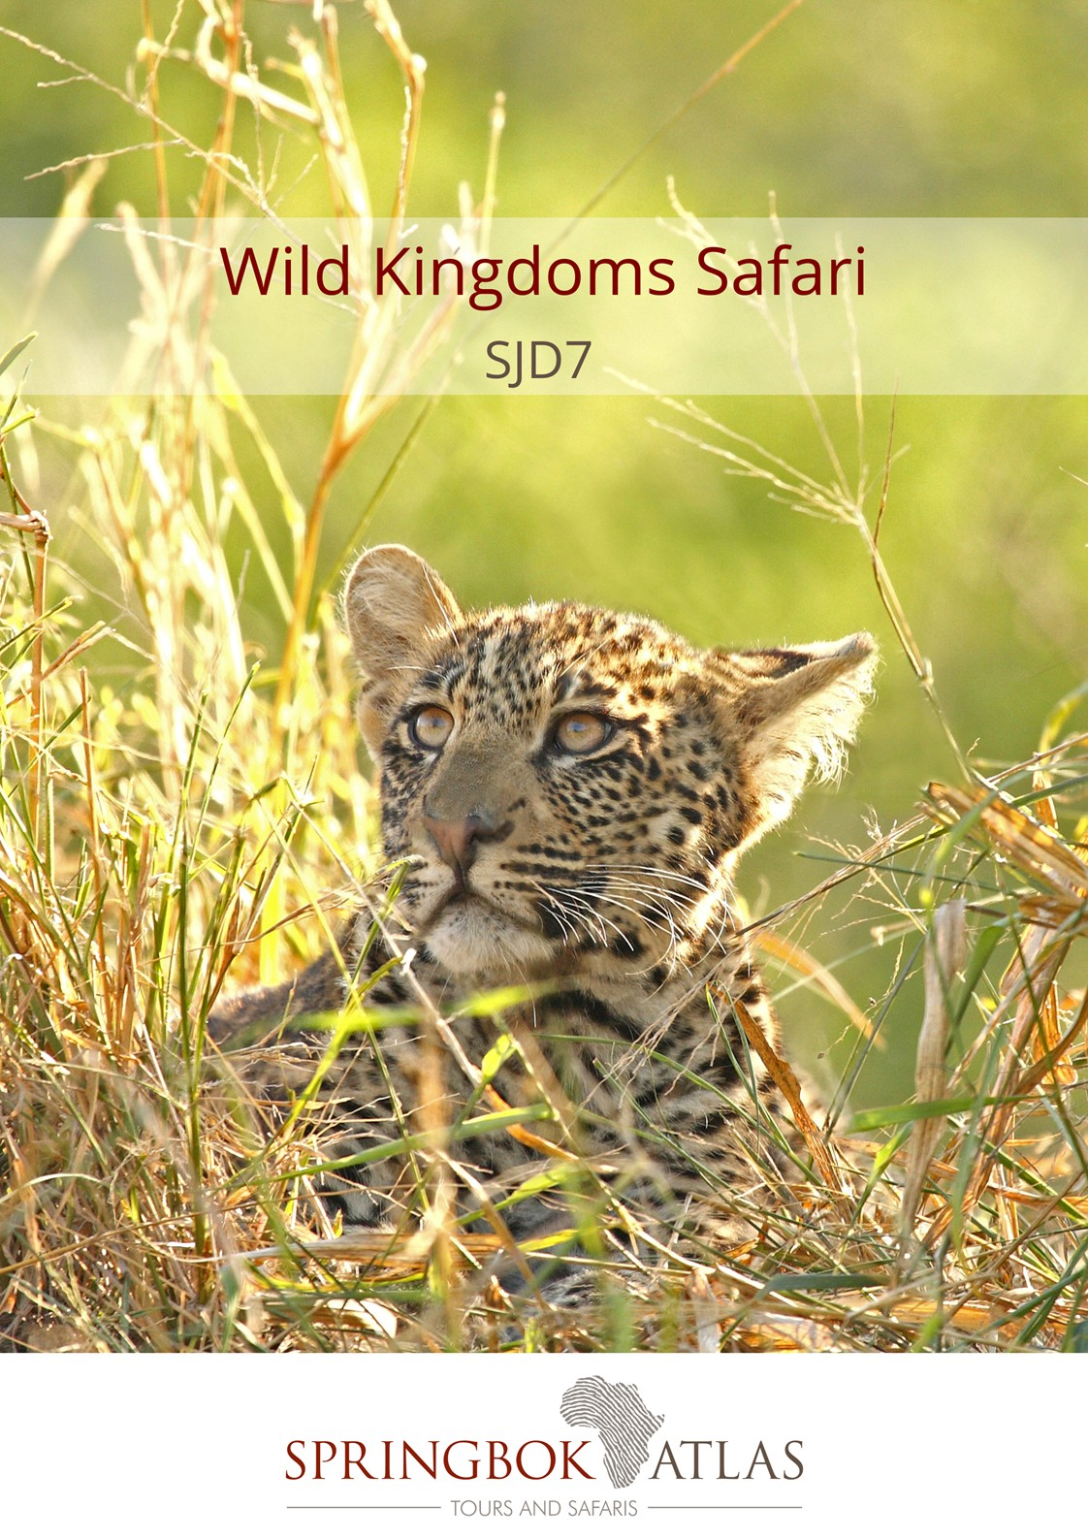
WILD KINGDOMS SAFARI

ITINERARY AT A GLANCE
DATE | ROUTING
DAY 1 - Sunday | JOHANNESBURG
DAY 2 - Monday | JOHANNESBURG – MPUMALANGA
DAY 3 - Tuesday | MPUMALANGA
DAY 4 - Wednesday | MPUMALANGA
DAY 5 - Thursday | MPUMALANGA – SWAZILAND
DAY 6 - Friday | SWAZILAND – ZULULAND
DAY 7 - Saturday | ZULULAND – DURBAN (UMHLANGA)
 | END OF TOUR

Meal Key

BB Bed and Breakfast
DBB Dinner, Bed and Breakfast
DBB+ Dinner, Bed and Breakfast plus one additional activity
DBB++ Dinner, Bed and Breakfast plus two additional activities
FB Full Board (includes 3 meals per day)
FB+ Full Board (includes 3 meals per day) plus one additional service
FB++ Full Board (includes 3 meals per day) plus two additional services
FI Fully Inclusive (includes all meals and local drinks), plus all activities

Minimum 2 guests / Maximum 25 guests
Selected departure dates

DURATION
7 days/6 nights

ROUTING
JOHANNESBURG – DURBAN (UMHLANGA)

DEPARTURE DATES
 | Dec 17 | Jan18 | Feb18 | Mar18 | Apr18 | May18 | Jun18 | Jul18 | Aug18 | Sep18 | Oct18 | Nov18 | Dec18
English | 3;10 | 7;14;21;28 | 4;11;18;25 | 4;11;18;25 | 1;8;15;22;29 | 6;13;20;27 | 3;10;17;24 | 1;8;15;22;29 | 5;12;19;26 | 2;9;16;23;30 | 7;14;21;28 | 4;11;18;25 | 2;9;16
German | 3 | 7 | 4 | 4 | 1 | 6 | 3 | 1 | 5 | 2 | 7 | 4 | 2

INCLUDES
6 breakfasts, 1 lunch, 1 dinner, accommodation, porterage, transportation, sightseeing as specified

VISA REQUIREMENTS
This tour travels through Swaziland. Please check visa requirements, as certain nationalities may require visas in order to travel through Swaziland.

RATES valid 01/12/17-30/04/18 & 01/09/18-31/12/18
R 18 960.00 per person sharing twin/double accommodation
R 23 660.00 per single person
RATES valid 01/05/18-31/08/18
R 18 370.00 per person sharing twin/double accommodation
R 22 820.00 per single person
Accommodation used:
Protea Hotel Wanderers (standard room) or similar x 1 night
Perry’s Bridge Hollow Boutique Hotel (standard room) or similar x 3 nights
Royal Swazi Sun (standard room) or similar x 1 night
Anew Hotel Hluhluwe (standard room) or similar x 1 night

LANGUAGE
All departures are in English. German commentary available on selected departure dates.

DAY 1 – SUNDAY JOHANNESBURG
On arrival in Johannesburg at OR Tambo International Airport, you’ll be met by your representative and transferred to your hotel. Johannesburg is the largest and most populous city in South Africa. It is also the source of a large-scale gold and diamond trade, due to its location on the mineral-rich Witwatersrand range of hills. The remainder of the day is at leisure & unescorted. Why not enjoy a sightseeing tour or simply relax at your hotel. At 19h00 we will meet up at reception for a briefing on the tour and a chance to meet fellow travellers.
Distance travelled today: 35 kms

DAY 2 – MONDAY JOHANNESBURG - MPUMALANGA
Depart Johannesburg after breakfast and head for Pretoria, South Africa’s capital city, for a short orientation tour, before continuing to the Mpumalanga Province, known as “Paradise Country”. Dropping several hundred feet into the lush subtropical region of the Lowveld, we travel via the historic towns of Dullstroom and Lydenburg. After traversing the famous Long Tom Pass, we travel via Sabie and arrive late afternoon into Hazyview, the safari hub of the Kruger National Park. [Breakfast]
Distance travelled today: 425 kms

DAY 3 – TUESDAY MPUMALANGA
After an early morning breakfast, we’ll drive along the spectacular “Panorama Route”, offering views of amazing scenery including the 26 kilometre-long Blyde River Canyon (home to the Three Rondavels), Bourke’s Luck Potholes’ and historic God’s Window, a breathtaking view (weather permitting) of the edge of the escarpment taking in the Kruger National Park.
We arrive back in Hazyview in the early afternoon, where the remainder of the day is at leisure to relax or join an afternoon game experience (optional and for own account). [Breakfast]
Distance travelled today: 320 kms

DAY 4 – WEDNESDAY MPUMALANGA
The day begins with early morning coffee or tea, followed by a thrilling open vehicle safari (with English speaking game ranger) through Kruger National Park with pre-packed breakfast. Kruger is one of the world’s greatest national parks, home to a stunning array of wildlife. Search for the ‘Big Five’ (rhino, buffalo, lion, leopard, and elephant) as well as prolific birdlife and numerous other game. The afternoon is at leisure at your hotel. Late afternoon open vehicle game drives are available (optional & for own account). [Breakfast]
Distance travelled today: 120 kms

DAY 5 – THURSDAY MPUMALANGA - SWAZILAND
This morning we travel to Swaziland, an independent Kingdom within the borders of South Africa, known for its lovely scenery, crafts and colourful indigenous culture. An interactive cultural experience introduces us to the charming people of Swaziland and their traditions. We travel via the capital city, Mbabane, and on to the beautiful Ezulwini Valley for a true African shopping experience at the Ezulwini Craft Market which is packed with woven baskets, beadwork and carvings.
Overnight in Swaziland. [Breakfast, Lunch & Dinner]
Distance travelled today: 310 kms

DAY 6 – FRIDAY SWAZILAND - ZULULAND
After breakfast we will continue south through Swaziland, before re-entering South Africa. Travel into Zululand, passing traditional round huts and endless vistas. There is an option to enjoy an afternoon open vehicle safari (optional and for own account with an English speaking game ranger) in the Hluhluwe-Umfolozi Game Reserve, which contains an immense diversity of fauna and flora and is particularly famous for its conservation of black and white rhino.
Overnight in Hluhluwe-Umfolozi region. [Breakfast]
Distance travelled today: 360 kms

DAY 7 – SATURDAY ZULULAND – DURBAN (UMHLANGA)
This morning we will join a cruise on Lake St Lucia (depending on favourable weather conditions) before departing for Durban. Our journey takes us past traditional Zulu Kraals, Eucalyptus plantations and sugar cane fields. We arrive in Durban in the early afternoon where the tour ends on arrival. [Breakfast]
Distance travelled today: 275 kms

STANDARD CONDITIONS OF BUSINESS

1 UNDERTAKING

Springbok Atlas undertakes to provide all services offered subject to the terms and conditions set out herein, which terms and conditions are accepted by the passenger.

2 DEFINITION

Springbok Atlas means: Cullinan Holdings LTD T/A Springbok Atlas Tours and Safaris

Passenger means: Individuals, groups, companies or other legal persons using the services offered by Springbok Atlas and includes the agents of passengers.

Services means: The provision of accommodations and/or transportation and/or meals as offered by Springbok Atlas and accepted by the Passenger.

3 TERMS OF PAYMENT

3.1 On confirmation of services - a deposit of 25 % of the quoted tour price is required (N.B. : For tours that include Blue Train and/or Private Game Reserves and Lodges, a different schedule of deposits, payments and cancellation fees apply. This will be provided when applicable.)
45 days before commencement of services - full payment plus rooming list is required.

Notes

i) Bookings made within 45 days of commencement of services must be accompanied by full payment of the tour plus rooming list.
ii) Where circumstances do not permit the timeous receipt of funds, explicit confirmation of transfer of funds will enable us to reserve services.

3.2 Payments may be deposited directly into the following bank account:

Springbok Atlas Pty Ltd
First National Bank of S.A. Ltd
Cape Town City Branch
Cape Town.

Account Number : 5462 676 2263
Bank Code : 201409
OR
Telegraphic Transfer
SWIFT CODE : FIRNZAJJ

3.3 If payments are made in negotiable foreign currency, the payer will be responsible for any short payment resulting from exchange rate fluctuations. The exchange rate applied by the official bankers of Springbok Atlas on receipt of moneys will be accepted as the applicable rate.

3.4 If the required deposit or final payment is not received by due date, Springbok Atlas reserves the right to withdraw services.

4 CANCELLATIONS

4.1 General Conditions

4.1.1 Cancellations made more than 45 days prior to arrival will not normally result in cancellation fees being charged. However;

4.1.2 Springbok Atlas reserves the right to recover any costs incurred or charges received from suppliers up to the date of cancellation.

4.1.3 In the event of services being cancelled 45 days or less, prior to arrival, the following cancellation fees will apply.

- 45 days to 36 days before commencement of services: 25% total quoted tour price due. (Subject to 2. above)
- 35 days to 16 days before commencement of services: 50% of total quoted tour price due. (Subject to 2. above)
- 15 days or less before commencement of services : 100% of the total quoted tour price due

We recommend that you ensure that your passengers take adequate personal cancellation insurance cover before departure from home.

4.2 Special Conditions

For tours that include services of certain suppliers with more stringent policies, e.g., National Parks Board, Blue Train, Private Lodges and others, different cancellation fees will be enforceable. These will be provided when applicable.

5 AIRLINES

Cancellations and refunds

In the event of cancellation or failure, for any reason whatsoever, to use confirmed space, as ticketed, 25% (twenty five percent) of the applicable airfare will be forfeited. A change of reservation constitutes a cancellation. Extension of ticket validity is no permitted, save when a passenger is hospitalised due to illness or in the event of death of a member of the passenger’s immediate family.

Responsibilities and booking conditions

All airfare reservations are arranged subject to the conditions imposed by the respective airline.

6 LUGGAGE

One suitcase and one overnight bag per person is allowed. Springbok Atlas accepts no responsibility for loss or damage to luggage or personal property from whatsoever cause arising. Passengers are advised to take up adequate insurance cover.

7 DELAYS

Springbok Atlas shall not be responsible for the consequences of any delays whether arising from accidents, breakdowns, or any other cause.

8 RESPONSIBILITY

Springbok Atlas carries comprehensive passenger liability insurance details of which will be made available on request. Springbok Atlas is not responsible for any damages sustained by any passenger as a result of any act or omission whatsoever of any hotel, airline or other person, notwithstanding the fact the Springbok Atlas acted as agent of such hotel, airline or other person.

9 LAW

The law of the Republic of South Africa shall govern the relationship between Springbok Atlas and the passenger and the Courts of the Republic of South Africa shall have sole jurisdiction in respect of any claims and/or disputes which may arise between Springbok Atlas and the passenger, or Agent.

