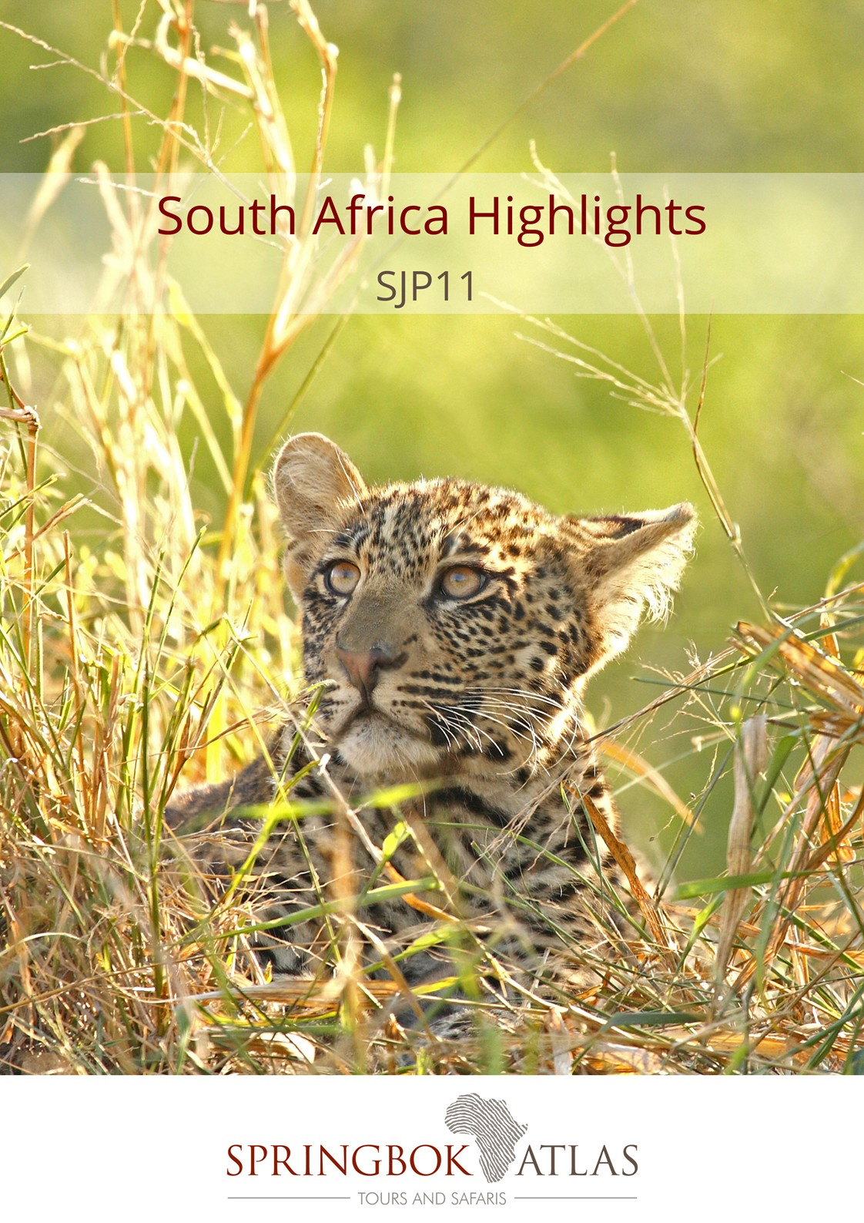
ITINERARY AT A GLANCE
DATE | ROUTING
DAY 1 – Tuesday | JOHANNESBURG – KRUGER NATIONAL PARK
DAY 2 – Wednesday | KRUGER NATIONAL PARK
DAY 3 – Thursday | MPUMALANGA
DAY 4 – Friday | MPUMALANGA – JOHANNESBURG – CAPE TOWN
DAY 5 – Saturday | CAPE TOWN
DAY 6 – Sunday | CAPE TOWN
DAY 7 – Monday | CAPE TOWN – PRINCE ALBERT
DAY 8 – Tuesday | PRINCE ALBERT - OUDTSHOORN
DAY 9 – Wednesday | OUDTSHOORN - KNYSNA
DAY 10 – Thursday | KNYSNA
DAY 11 – Friday | KNYSNA – PORT ELIZABETH
 | END OF TOUR

Meal Key

BB Bed and Breakfast
DBB Dinner, Bed and Breakfast
DBB+ Dinner, Bed and Breakfast plus one additional activity
DBB++ Dinner, Bed and Breakfast plus two additional activities
FB Full Board (includes 3 meals per day)
FB+ Full Board (includes 3 meals per day) plus one additional service
FB++ Full Board (includes 3 meals per day) plus two additional services
FI Fully Inclusive (includes all meals and local drinks), plus all activities

Minimum 2 guests / Maximum 25 guests
Selected departure dates

DURATION
11 days/10 nights

ROUTING
JOHANNESBURG – PORT ELIZABETH

INCLUDES
10 breakfasts, 1 lunch, 4 dinners, accommodation, transportation, open vehicle safaris, porterage and sightseeing as specified

EXCLUDES
Flight and departure tax between Johannesburg and Cape Town
Please book JNB/CPT flight to depart Johannesburg after 15h00 (Day 4)

NOTE
The Full Day Cape Peninsula Tour scheduled for Day 5 will be moved to Day 6 on the day of the Two Oceans Marathon in Cape Town

DEPARTURE DATES
 | Dec17 | Jan18 | Feb18 | Mar18 | Apr18 | May18 | Jun18 | Jul18 | Aug18 | Sep18 | Oct18 | Nov18 | Dec18
German | - | - | 6 | 6 | - | - | - | - | 14 | 4 | 2 | 6 | -
English | 12 | 2;16;30 | 6;13;20;27 | 6;13;20;27 | 10;24 | 8;22 | 5;19 | 3;17;31 | 14;28 | 4;11;18;25 | 2;9;16;23;30 | 6;13;20;27 | 11

We offer 3 different accommodation options at certain hotels on the tour, which guests can choose from:
- The Comfortable Option offers “standard room” types
- The Cut Above Option offers accommodation in a slightly higher room category than “standard rooms”
- The Premium Option offers accommodation in “superior room” types

The “Cut Above” and “Premium” options feature upgraded accommodation at certain hotels on the tour (subject to availability at the time of booking).

RACK RATES
“Comfortable Option”:
Valid 01/12/17-31/03/18 & 01/10/18-31/12/18
R 28 400.00 per person sharing twin/double accommodation
R 34 600.00 per single person
Valid 01/04/18-30/09/18
R 27 100.00 per person sharing twin/double accommodation
R 32 450.00 per single person
Accommodation used:
Protea Hotel Kruger Gate (standard room) or similar x 3 nights
Protea Hotel Sea Point (superior room) or similar x 3 nights
Swartberg Hotel (standard room) or similar x 1 night
La Plume Guest House (luxury room) or similar x 1 night
Rex Hotel (standard room) or similar x 2 nights

“A cut above Option”:
Valid 01/12/17-31/03/18 & 01/10/18-31/12/18
R 29 100.00 per person sharing twin/double accommodation
R 35 800.00 per single person
Valid 01/04/18-30/09/18
R 27 700.00 per person sharing twin/double accommodation
R 33 600.00 per single person
Accommodation used:
Protea Hotel Kruger Gate (standard room) or similar x 3 nights
Protea Hotel Sea Point (superior room) or similar x 3 nights
Swartberg Hotel (chalet room) or similar x 1 night
La Plume Guest House (honeymoon suite) or similar x 1 night
Rex Hotel (studio luxury apartments) or similar x 2 nights
“Premium Option”:
Valid 01/12/17-31/03/18 & 01/10/18-31/12/18
R 29 400.00 per person sharing twin/double accommodation
R 37 100.00 per single person
Valid 01/04/18-30/09/18
R 27 900.00 per person sharing twin/double accommodation
R 34 600.00 per single person
Accommodation used:
Protea Hotel Kruger Gate (standard room) or similar x 3 nights
Protea Hotel Sea Point (superior room) or similar x 3 nights
Swartberg Hotel (chalet room) or similar x 1 night
La Plume Guest House (superior suite) or similar x 1 night
Rex Hotel (studio luxury apartments) or similar x 2 nights

Please note that the guests will be travelling on the same vehicle, but will overnight in different room types at certain hotels, depending on their chosen accommodation option and subject to availability of the chosen room category at the time of booking. (Comfortable / Cut Above / Premium)

LANGUAGE
All departures are in English. German commentary is available on selected departure dates.

DAY 1 – TUESDAY JOHANNESBURG - KRUGER NATIONAL PARK
This morning you will be collected from your hotel, heading east to the Mpumalanga region. After freshening up at your lodge enter the world famous Kruger National Park and spend the afternoon game viewing in your closed touring vehicle. The park offers some of the best game viewing and wildlife opportunities in the world – and the visitor will soon appreciate the challenges of managing this unique reserve. Return to the lodge for dinner and overnight. [Dinner]

DAY 2 – WEDNESDAY KRUGER NATIONAL PARK
The day begins with early morning coffee or tea, followed by a thrilling open vehicle game drive (with English speaking game ranger) through Kruger National Park with pre-packed breakfast. Your guide will endeavour to spoil you with sightings of the “Big Five”, general game and prolific bird life. Return to the lodge for lunch (own account) and a short siesta. In the afternoon we will journey once again through the magnificent expanses of the Kruger National Park, unrivalled in its diversity of flora and fauna. Enjoy an afternoon of game viewing in your closed touring vehicle pursuing the Big Five and other rare and endangered species. Optional (own account) open vehicle game drives are available.
Return to the lodge for dinner and overnight. [Breakfast & Dinner]

DAY 3 – THURSDAY MPUMALANGA
Enjoy breakfast before setting out to explore the magnificent Panorama Route, one of the most scenic routes in the region, offering glorious views, spectacular landscapes and exquisite waterfalls. Visit majestic sights including God’s Window, the Three Rondawels and Blyderiver Canyon – the third largest canyon of its kind in the world, Bourke’s Luck Potholes and the charming village of Graskop, one of the first gold mining camps in the country. Optional (own account) open vehicle game drives are available, should you prefer not to join the Panorama Route tour.
Return to the lodge for dinner and overnight. [Breakfast & Dinner]

DAY 4 – FRIDAY MPUMALANGA – JOHANNESBURG – CAPE TOWN
Enjoy breakfast before starting the return journey to Johannesburg. Arrive in Johannesburg, at OR Tambo International Airport, at approximately 14h30, for your onward flight to Cape Town. On arrival in Cape Town, the oldest city in South Africa, spectacularly set at the foot of Table Mountain, you’ll be met and transferred to your hotel, where the remainder of the day is yours to relax or explore the city (unescorted). [Breakfast]

DAY 5 – SATURDAY CAPE TOWN
Continue your journey of discovery, by joining a full day tour of the Cape Peninsula. Drive through Sea Point, the seaside village of Hout Bay and then to Cape Point where (by tradition) it is said that the Atlantic and Indian Oceans meet. Return to Cape Town through the historic naval base of Simon’s Town and Muizenberg to visit Kirstenbosch Botanical Gardens, a centre for the preservation of the region’s unique flora.
Overnight in Cape Town. [Breakfast]

DAY 6 – SUNDAY CAPE TOWN (UNESCORTED)
Enjoy a full day at leisure. Perhaps join a sightseeing tour to Table Mountain (own account) or simply explore the city. Although a small city, Cape Town is packed with sightseeing attractions, excellent bars, cafes and restaurants as well as colourful craft markets. There is also the Two Oceans Aquarium, Robben Island or alternatively relax on one of Cape Town’s many beaches.
Overnight in Cape Town. [Breakfast]

DAY 7 – MONDAY CAPE TOWN – PRINCE ALBERT
Travel through the picturesque Hex River Valley, surrounded by magnificent mountains. This area is considered to be the biggest producer of table grapes in South Africa. Continue to Matjiesfontein, where a part of the local hotel served as a convalescent hospital for British officers during the Anglo-Boer War. The entire village was declared a National Heritage Site in 1975 and is today a charming, beautifully restored throwback to the late Victorian era. The journey continues to Prince Albert, another delightful village, dating back to 1762. The town is known for its sun-ripened fresh and dried fruit, vineyards, olives and local cheese.
Overnight in Prince Albert. [Breakfast]

DAY 8 – TUESDAY PRINCE ALBERT – OUDTSHOORN
After breakfast we have the opportunity to sample some of the locally produced olives before travelling through the spectacular Meiringspoort Pass and Waterfall, part of a UNESCO World Heritage Site, with breathtaking rock formations and jaw-dropping beauty. The winding road takes us through the Swartberg Mountains to the quaint Little Karoo village of De Rust. Continue to Oudtshoorn, the ostrich capital of the world and home to the spectacular limestone caverns of the Cango Caves. Enjoy a wine tasting at a local wine estate before setting off on a tour of the Cango Caves, one of the world’s great natural wonders, sculpted by nature through the ages. In the afternoon, visit an Ostrich Farm for a guided tour.
Overnight in Oudtshoorn. [Breakfast & Dinner]

DAY 9 – WEDNESDAY OUDTSHOORN - KNYSNA
After breakfast, travel over the Outeniqua Pass to George, the sixth oldest town in South Africa, with many historical landmarks such as the Slave Tree and King Edward VII Library building; said to be the best example of Edwardian architecture in the town. The tour travels via Wilderness, an attractive holiday resort to Knysna, known as the oyster box of South Africa, nestling on the banks of a beautiful lagoon in the heart of the Garden Route. Enjoy a lagoon cruise to the Featherbed Nature Reserve, where you can take a trailer ride to the top of the Western Head to enjoy panoramic views of the town and lagoon, returning for lunch under the milkwood trees. The afternoon is at leisure to further explore this charming town set around a natural harbour lagoon.
Overnight in Knysna. [Breakfast & Lunch]

DAY 10 – THURSDAY KNYSNA
Today you’ll have the opportunity to explore the natural beauty of the Knysna area. Your journey will include a visit to the Garden of Eden, set in the lush, green, indigenous Knysna forest. The major attraction is the forest itself, beautiful yellow wood trees, thick green foliage and streams. Afterwards you’ll have the opportunity to visit Monkeyland Primate Sanctuary, where you will be able to see a variety of primates, roaming free in the forest. The sanctuary is well known for its efforts to rehabilitate and free previously caged primates. The tour continues to the famous Eastern Head, where you will enjoy spectacular views of the Knysna Heads (weather permitting). Afterwards you’ll travel to Brenton on Sea, a breathtaking holiday location and a nature lover’s paradise with its unspoilt beaches and peaceful surroundings. The remainder of the afternoon will be at leisure.
Overnight in Knysna. [Breakfast]

DAY 11 – FRIDAY KNYSNA – PORT ELIZABETH
After breakfast, you’ll be transferred (unescorted, driver only) to Port Elizabeth. You’ll head eastwards along the Tsitsikamma Forest to Port Elizabeth, known as the “friendly city” with a wonderful climate. The tour ends on arrival in Port Elizabeth. [B]
Guests may disembark, on request, at Port Elizabeth Airport. [Breakfast]

STANDARD CONDITIONS OF BUSINESS

1 UNDERTAKING

Springbok Atlas undertakes to provide all services offered subject to the terms and conditions set out herein, which terms and conditions are accepted by the passenger.

2 DEFINITION

Springbok Atlas means: Cullinan Holdings LTD T/A Springbok Atlas Tours and Safaris

Passenger means: Individuals, groups, companies or other legal persons using the services offered by Springbok Atlas and includes the agents of passengers.

Services means: The provision of accommodations and/or transportation and/or meals as offered by Springbok Atlas and accepted by the Passenger.

3 TERMS OF PAYMENT

3.1 On confirmation of services - a deposit of 25 % of the quoted tour price is required (N.B. : For tours that include Blue Train and/or Private Game Reserves and Lodges, a different schedule of deposits, payments and cancellation fees apply. This will be provided when applicable.)
45 days before commencement of services - full payment plus rooming list is required.

Notes

i) Bookings made within 45 days of commencement of services must be accompanied by full payment of the tour plus rooming list.
ii) Where circumstances do not permit the timeous receipt of funds, explicit confirmation of transfer of funds will enable us to reserve services.

3.2 Payments may be deposited directly into the following bank account:

Springbok Atlas Pty Ltd
First National Bank of S.A. Ltd
Cape Town City Branch
Cape Town.

Account Number : 5462 676 2263
Bank Code : 201409
OR
Telegraphic Transfer
SWIFT CODE : FIRNZAJJ

3.3 If payments are made in negotiable foreign currency, the payer will be responsible for any short payment resulting from exchange rate fluctuations. The exchange rate applied by the official bankers of Springbok Atlas on receipt of moneys will be accepted as the applicable rate.

3.4 If the required deposit or final payment is not received by due date, Springbok Atlas reserves the right to withdraw services.

4 CANCELLATIONS

4.1 General Conditions

4.1.1 Cancellations made more than 45 days prior to arrival will not normally result in cancellation fees being charged. However;

4.1.2 Springbok Atlas reserves the right to recover any costs incurred or charges received from suppliers up to the date of cancellation.

4.1.3 In the event of services being cancelled 45 days or less, prior to arrival, the following cancellation fees will apply.

- 45 days to 36 days before commencement of services: 25% total quoted tour price due. (Subject to 2. above)
- 35 days to 16 days before commencement of services: 50% of total quoted tour price due. (Subject to 2. above)
- 15 days or less before commencement of services : 100% of the total quoted tour price due

We recommend that you ensure that your passengers take adequate personal cancellation insurance cover before departure from home.

4.2 Special Conditions

For tours that include services of certain suppliers with more stringent policies, e.g., National Parks Board, Blue Train, Private Lodges and others, different cancellation fees will be enforceable. These will be provided when applicable.

5 AIRLINES

Cancellations and refunds

In the event of cancellation or failure, for any reason whatsoever, to use confirmed space, as ticketed, 25% (twenty five percent) of the applicable airfare will be forfeited. A change of reservation constitutes a cancellation. Extension of ticket validity is no permitted, save when a passenger is hospitalised due to illness or in the event of death of a member of the passenger’s immediate family.

Responsibilities and booking conditions

All airfare reservations are arranged subject to the conditions imposed by the respective airline.

6 LUGGAGE

One suitcase and one overnight bag per person is allowed. Springbok Atlas accepts no responsibility for loss or damage to luggage or personal property from whatsoever cause arising. Passengers are advised to take up adequate insurance cover.

7 DELAYS

Springbok Atlas shall not be responsible for the consequences of any delays whether arising from accidents, breakdowns, or any other cause.

8 RESPONSIBILITY

Springbok Atlas carries comprehensive passenger liability insurance details of which will be made available on request. Springbok Atlas is not responsible for any damages sustained by any passenger as a result of any act or omission whatsoever of any hotel, airline or other person, notwithstanding the fact the Springbok Atlas acted as agent of such hotel, airline or other person.

9 LAW

The law of the Republic of South Africa shall govern the relationship between Springbok Atlas and the passenger and the Courts of the Republic of South Africa shall have sole jurisdiction in respect of any claims and/or disputes which may arise between Springbok Atlas and the passenger, or Agent.

