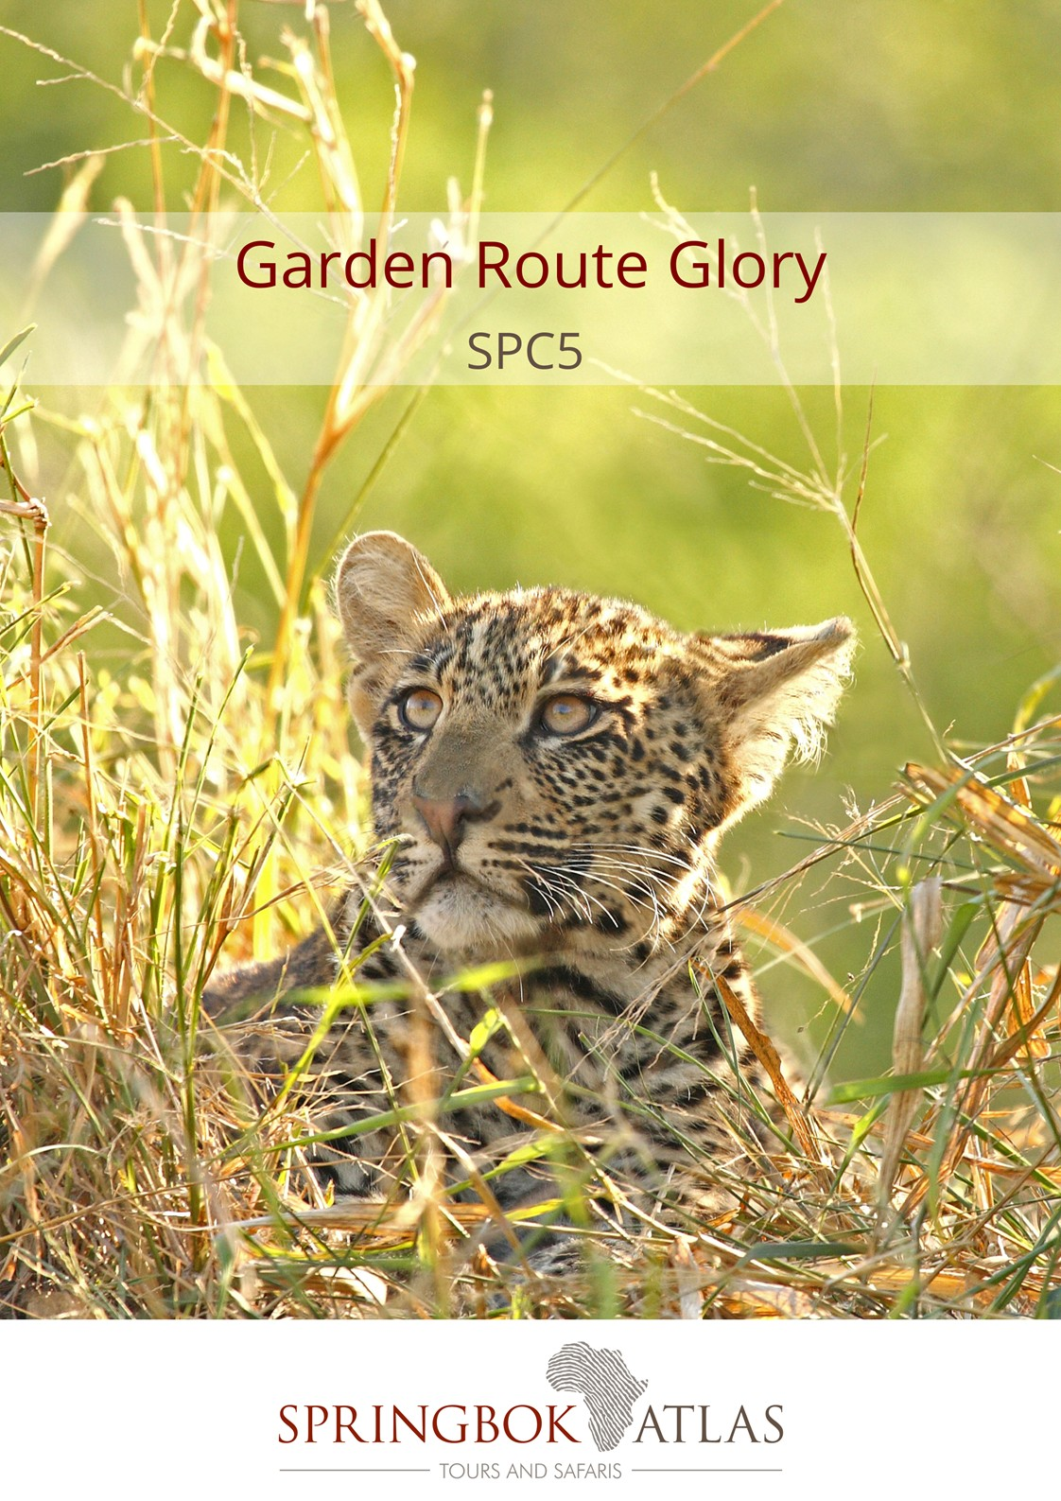
ITINERARY AT A GLANCE
DATE | ROUTING
DAY 1 - Sunday | PORT ELIZABETH – KNYSNA
DAY 2 - Monday | KNYSNA
DAY 3 - Tuesday | KNYSNA – OUDTSHOORN
DAY 4 - Wednesday | OUDTSHOORN – FRANSCHHOEK
DAY 5 - Thursday | FRANSCHHOEK – CAPE TOWN
 | END OF TOUR

Meal Key

BB Bed and Breakfast
DBB Dinner, Bed and Breakfast
DBB+ Dinner, Bed and Breakfast plus one additional activity
DBB++ Dinner, Bed and Breakfast plus two additional activities
FB Full Board (includes 3 meals per day)
FB+ Full Board (includes 3 meals per day) plus one additional service
FB++ Full Board (includes 3 meals per day) plus two additional services
FI Fully Inclusive (includes all meals and local drinks), plus all activities
Minimum 2 guests / Maximum 25 guests
Selected departure dates

DURATION
5 days/4 nights

ROUTING
PORT ELIZABETH - CAPE TOWN

DEPARTURE DATES
 | Dec 17 | Jan18 | Feb18 | Mar18 | Apr18 | May18 | Jun18 | Jul18 | Aug18 | Sep18 | Oct18 | Nov18 | Dec18
English | 10;17 | 14;21;28 | 4;11;18;25 | 4;11;18;25 | 1;8;15;22;29 | 6;13;20;27 | 3;10;17;24 | 1;8;15;22;29 | 5;12;19;26 | 2;9;16;23;30 | 7;14;21;28 | 4;11;18;25 | 2;9;16;23
German | 10 | 14 | 11 | 11 | 8 | 13 | 10 | 8 | 12 | 9 | 14 | 11 | 9

INCLUDES
4 breakfasts, 2 lunches, 1 dinner, accommodation, porterage, transportation, and sightseeing as specified.

We offer 3 different accommodation options at certain hotels on the tour, which guests can choose from:
- The Comfortable Option offers “standard room” types
- The Cut Above Option offers accommodation in a slightly higher room category than “standard rooms”
- The Premium Option offers accommodation in “superior room” types

The “Cut Above” and “Premium” options feature upgraded accommodation at certain hotels on the tour (subject to availability at the time of booking).

“Comfortable Option”:
Rates valid 01/12/17-30/04/18 & 01/08/18-31/12/18
R 12 160.00 per person sharing twin/double accommodation
R 13 960.00 per single person
Rates valid 01/05/18-31/07/18
R 11 610.00 per person sharing twin/double accommodation
R 13 210.00 per single person
Accommodation used:
Rex Hotel (standard room) or similar x 2 nights
Hlangana Lodge (standard room) or similar x 1 night
Protea Hotel Franschhoek (standard room) or similar x 1 night

“A cut above Option”:
Rates valid 01/12/17-30/04/18 & 01/08/18-31/12/18
R 12 670.00 per person sharing twin/double accommodation
R 14 840.00 per single person
Rates valid 01/05/18-31/07/18
R 12 260.00 per person sharing twin/double accommodation
R 14 415.00 per single person
Accommodation used:
Rex Hotel (studio luxury apartment) or similar x 2 nights
Hlangana Lodge (standard room) or similar x 1 night
Protea Hotel Franschhoek (standard room) or similar x 1 night

“Premium Option”:
Rates valid 01/12/17-30/04/18 & 01/08/18-31/12/18
R 13 800.00 per person sharing twin/double accommodation
R 16 200.00 per single person
Rates valid 01/05/18-31/07/18
R 13 100.00 per person sharing twin/double accommodation
R 15 330.00 per single person
Accommodation used:
Rex Hotel (studio luxury apartment) or similar x 2 nights
Hlangana Lodge (superior room) or similar x 1 night
Protea Hotel Franschhoek (standard room) or similar x 1 night

Please note that the guests will be travelling on the same vehicle, but will overnight in different room types at certain hotels, depending on their chosen accommodation option and subject to availability of the chosen room category at the time of booking. (Comfortable / Cut Above / Premium).

LANGUAGE
All departures are in English. German commentary is available on selected departure dates.

DAY 1 – SUNDAY PORT ELIZABETH - KNYSNA
We depart Port Elizabeth and head westwards to explore the magnificent beauty of the indigenous Tsitsikamma Forest. Visit the spectacularly beautiful Tsitsikamma National Park and Storms River Mouth (weather permitting). We’ll arrive at our hotel in Knysna, known as the oyster box of South Africa, nestling on the banks of a beautiful lagoon in the heart of the Garden Route. Overnight in Knysna. [Dinner]
Distance travelled today: 360 kms

DAY 2 – MONDAY KNYSNA
After a leisurely breakfast we’ll enjoy a lagoon cruise to the Featherbed Nature Reserve, where we can take a trailer ride to the top of the Western Head to enjoy panoramic views of the town and lagoon, returning for lunch under the milkwood trees. The afternoon is at leisure to further explore this charming town set around a natural harbour lagoon. [Breakfast & Lunch]
Distance travelled today: 15 kms

DAY 3 – TUESDAY KNYSNA - OUDTSHOORN
Travel through the Outeniqua Pass to Oudtshoorn, known as the “ostrich capital” and the centre of the world’s Ostrich farming industry. We’ll visit an Ostrich Farm for a guided tour and light lunch, before taking a tour of the spectacular limestone caverns of the Cango Caves, one of the world’s great natural wonders, sculpted by nature through the ages. We will arrive at our hotel in the late afternoon, in time to check in and relax before dinner (for own account).
Overnight in Oudtshoorn. [Breakfast & Lunch]
Distance travelled today: 210 kms

DAY 4 – WEDNESDAY OUDTSHOORN - FRANSCHHOEK
There is an option (for own account and subject to availability) to enjoy an early morning Meerkat Safari. Witness these incredible wild habituated creatures emerging out of their burrows, in time to soak up the sun before they head about their daily activities (weather permitting). After this thrilling experience, head back for a delicious breakfast. After breakfast, the journey continues through the ‘Little Karoo’ to Barrydale, where you will have the opportunity to visit a local farm school, interact with the children and teachers, spending time with them in the classroom learning more about the local farming community, before travelling to Montagu, a picturesque and historic spa town. (The school visit is subject to the school being open). Continue to Franschhoek, a picturesque village surrounded by spectacular vineyards, where French Huguenots settled more than 300 years ago, bringing with them their age-old French wine and food culture. Overnight in Franschhoek [Breakfast]
Distance travelled today: 390 kms

DAY 5 – THURSDAY FRANSCHHOEK – CAPE TOWN
After a leisurely breakfast, our story telling guide will take us on a tour through Franschhoek village, sharing with us the fascinating history of the French Huguenots and the Huguenot Memorial Museum. Enjoy a wine tasting before continuing to Cape Town, the oldest city in South Africa, spectacularly set at the foot of Table Mountain where the tour ends on arrival. [Breakfast]
Distance travelled today: 80 kms

STANDARD CONDITIONS OF BUSINESS

1 UNDERTAKING

Springbok Atlas undertakes to provide all services offered subject to the terms and conditions set out herein, which terms and conditions are accepted by the passenger.

2 DEFINITION

Springbok Atlas means: Cullinan Holdings LTD T/A Springbok Atlas Tours and Safaris

Passenger means: Individuals, groups, companies or other legal persons using the services offered by Springbok Atlas and includes the agents of passengers.

Services means: The provision of accommodations and/or transportation and/or meals as offered by Springbok Atlas and accepted by the Passenger.

3 TERMS OF PAYMENT

3.1 On confirmation of services - a deposit of 25 % of the quoted tour price is required (N.B. : For tours that include Blue Train and/or Private Game Reserves and Lodges, a different schedule of deposits, payments and cancellation fees apply. This will be provided when applicable.)
45 days before commencement of services - full payment plus rooming list is required.

Notes

i) Bookings made within 45 days of commencement of services must be accompanied by full payment of the tour plus rooming list.
ii) Where circumstances do not permit the timeous receipt of funds, explicit confirmation of transfer of funds will enable us to reserve services.

3.2 Payments may be deposited directly into the following bank account:

Springbok Atlas Pty Ltd
First National Bank of S.A. Ltd
Cape Town City Branch
Cape Town.

Account Number : 5462 676 2263
Bank Code : 201409
OR
Telegraphic Transfer
SWIFT CODE : FIRNZAJJ

3.3 If payments are made in negotiable foreign currency, the payer will be responsible for any short payment resulting from exchange rate fluctuations. The exchange rate applied by the official bankers of Springbok Atlas on receipt of moneys will be accepted as the applicable rate.

3.4 If the required deposit or final payment is not received by due date, Springbok Atlas reserves the right to withdraw services.

4 CANCELLATIONS

4.1 General Conditions

4.1.1 Cancellations made more than 45 days prior to arrival will not normally result in cancellation fees being charged. However;

4.1.2 Springbok Atlas reserves the right to recover any costs incurred or charges received from suppliers up to the date of cancellation.

4.1.3 In the event of services being cancelled 45 days or less, prior to arrival, the following cancellation fees will apply.

- 45 days to 36 days before commencement of services: 25% total quoted tour price due. (Subject to 2. above)
- 35 days to 16 days before commencement of services: 50% of total quoted tour price due. (Subject to 2. above)
- 15 days or less before commencement of services : 100% of the total quoted tour price due

We recommend that you ensure that your passengers take adequate personal cancellation insurance cover before departure from home.

4.2 Special Conditions

For tours that include services of certain suppliers with more stringent policies, e.g., National Parks Board, Blue Train, Private Lodges and others, different cancellation fees will be enforceable. These will be provided when applicable.

5 AIRLINES

Cancellations and refunds

In the event of cancellation or failure, for any reason whatsoever, to use confirmed space, as ticketed, 25% (twenty five percent) of the applicable airfare will be forfeited. A change of reservation constitutes a cancellation. Extension of ticket validity is no permitted, save when a passenger is hospitalised due to illness or in the event of death of a member of the passenger’s immediate family.

Responsibilities and booking conditions

All airfare reservations are arranged subject to the conditions imposed by the respective airline.

6 LUGGAGE

One suitcase and one overnight bag per person is allowed. Springbok Atlas accepts no responsibility for loss or damage to luggage or personal property from whatsoever cause arising. Passengers are advised to take up adequate insurance cover.

7 DELAYS

Springbok Atlas shall not be responsible for the consequences of any delays whether arising from accidents, breakdowns, or any other cause.

8 RESPONSIBILITY

Springbok Atlas carries comprehensive passenger liability insurance details of which will be made available on request. Springbok Atlas is not responsible for any damages sustained by any passenger as a result of any act or omission whatsoever of any hotel, airline or other person, notwithstanding the fact the Springbok Atlas acted as agent of such hotel, airline or other person.

9 LAW

The law of the Republic of South Africa shall govern the relationship between Springbok Atlas and the passenger and the Courts of the Republic of South Africa shall have sole jurisdiction in respect of any claims and/or disputes which may arise between Springbok Atlas and the passenger, or Agent.

