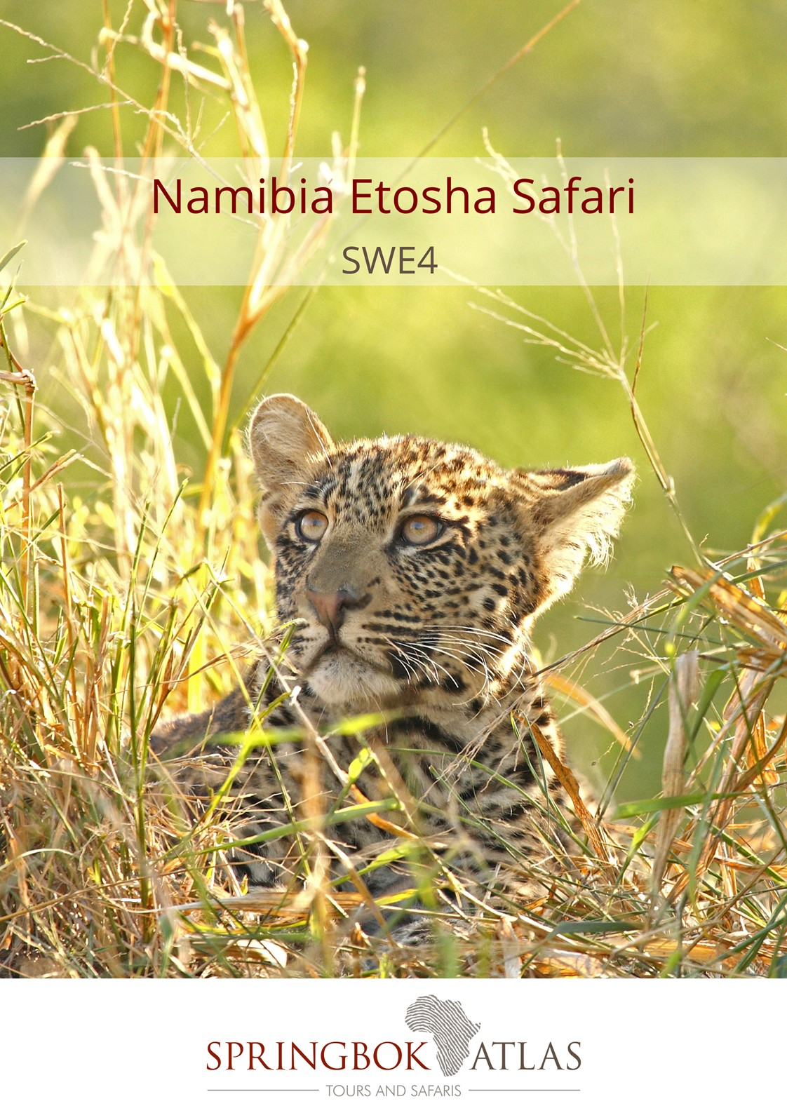

ITINERARY AT A GLANCE
DATE | ROUTING
DAY 1 - Thursday | WINDHOEK – ETOSHA NATIONAL PARK
DAY 2 - Friday | ETOSHA NATIONAL PARK
DAY 3 - Saturday | ETOSHA NATIONAL PARK
DAY 4 - Sunday | ETOSHA NATIONAL PARK - WINDHOEK
 | END OF TOUR

Meal Key

BB Bed and Breakfast
DBB Dinner, Bed and Breakfast
DBB+ Dinner, Bed and Breakfast plus one additional activity
DBB++ Dinner, Bed and Breakfast plus two additional activities
FB Full Board (includes 3 meals per day)
FB+ Full Board (includes 3 meals per day) plus one additional service
FB++ Full Board (includes 3 meals per day) plus two additional services
FI Fully Inclusive (includes all meals and local drinks), plus all activities
LP Lunch Pack
BP Breakfast Pack

Minimum 2 guests / Maximum 12 guests

Selected departure dates

DURATION:

4 Days/3 Nights

ROUTING
WINDHOEK - WINDHOEK

DEPARTURE DATES
 | Nov17 | Dec17 | Jan18 | Feb18 | Mar18 | Apr18 | May18 | Jun18 | Jul18 | Aug18 | Sep18 | Oct18
Ger/Eng | 23 | 21 | 25 | 15 | 1;15;29 | 19 | 3;17;31 | 14;28 | 12;19 | 2;9;16;30 | 6;13;27 | 11;18

INCLUDES

3 breakfasts, 3 dinners, accommodation, bottled water on board, transport in air-conditioned vehicles, porterage, entrance fees and sightseeing as specified

VISA REQUIREMENTS
Please check visa requirements, as certain nationalities may require visas in order to travel through Namibia

LANGUAGE
All departures are in dual language German/English commentary. English commentary is available on selected dates

Rates ex Windhoek valid 01/11/2017 - 31/10/18
NAD 13 600.00 per person sharing
NAD 14 840.00 per single person

Accommodation used:
Etosha Safari Camp or similar x 2 nights
Mokuti Etosha Lodge or similar x 1 night

Option to upgrade to Etosha Safari Lodge on Day 1 & 2 (subject to availability at the time of booking) at an additional cost of NAD 770.00 per person sharing per night / NAD 950.00 per single person per night

The tour departs from Windhoek on selected Thursdays

The Windhoek departure might include an unescorted transfer (driver only) to Outjo from where guests will meet up with the guide and rest of group.

DAY 1 – THURSDAY WINDHOEK - ETOSHA NATIONAL PARK

Depart from Windhoek and continue via the little town of Outjo. Lunch stop (for own account) - possibly meet fellow guests that are joining the Etosha tour. From there continue to Etosha National Park. Arrive in the early afternoon and undertake your first game drive, in your closed touring vehicle, into the park. [Dinner]

DAY 2 – FRIDAY ETOSHA NATIONAL PARK

The morning will be spent in the Etosha National Park, exploring the waterholes along this enormous saltpan, in your closed touring vehicle. Return to the lodge for lunch (lunch for own account). There will be another opportunity in the afternoon for a game drive (in the closed touring vehicle) in the Etosha National park. There are close to 114 species of mammal in Etosha, including the black faced impala and the threatened black and white rhino. The Etosha Pan (a flat calcrete depression), contains water only after very good rains and sometimes only for a few days each year, but is enough to stimulate the growth of a blue green algae which lures thousands of flamingos. [Breakfast & Dinner]

DAY 3 – SATURDAY ETOSHA NATIONAL PARK

Enjoy a full day exploring this world famous National Park, in your closed touring vehicle. Your guide will introduce you to the complex subject of managing such an enormous reserve, that’s considered to be one of the world’s great wildlife sanctuaries. There will be an opportunity to buy a take away lunch at one of the rest camps inside the Etosha National Park (lunch for own account). [Breakfast & Dinner]

DAY 4 – SUNDAY ETOSHA NATIONAL PARK - WINDHOEK

After breakfast, travel south towards Otjiwarongo. Continue towards Windhoek via Okahandja where we will visit a local handicraft market. Tour ends on arrival in Windhoek late afternoon. [Breakfast]
STANDARD CONDITIONS OF BUSINESS

1 UNDERTAKING

Springbok Atlas undertakes to provide all services offered subject to the terms and conditions set out herein, which terms and conditions are accepted by the passenger.

2 DEFINITION

Springbok Atlas means: Cullinan Holdings (Pty) Ltd T/A Springbok Atlas Tours & Safaris

Passenger means: Individuals, groups, companies or other legal persons using the services offered by Springbok Atlas and includes the agents of passengers.

Services means: The provision of accommodations and/or transportation and/or meals as offered by Springbok Atlas and accepted by the Passenger.

3 TERMS OF PAYMENT

3.1 On confirmation of services - a deposit of 25 % of the quoted tour price is required (N.B. : For tours that include Blue Train and/or Private Game Reserves and Lodges, a different schedule of deposits, payments and cancellation fees apply. This will be provided when applicable.)
45 days before commencement of services - full payment plus rooming list is required.

Notes

i) Bookings made within 45 days of commencement of services must be accompanied by full payment of the tour plus rooming list.
ii) Where circumstances do not permit the timeous receipt of funds, explicit confirmation of transfer of funds will enable us to reserve services.

3.2 Payments may be deposited directly into the following bank account:

Springbok Atlas Pty Ltd
First National Bank of S.A. Ltd
Cape Town City Branch
Cape Town.

Account Number : 5462 676 2263
Bank Code : 201409
OR
Telegraphic Transfer
SWIFT CODE : FIRNZAJJ

3.3 If payments are made in negotiable foreign currency, the payer will be responsible for any short payment resulting from exchange rate fluctuations. The exchange rate applied by the official bankers of Springbok Atlas on receipt of moneys will be accepted as the applicable rate.

3.4 If the required deposit or final payment is not received by due date, Springbok Atlas reserves the right to withdraw services.

4 CANCELLATIONS

4.1 General Conditions

4.1.1 Cancellations made more than 45 days prior to arrival will not normally result in cancellation fees being charged. However;

4.1.2 Springbok Atlas reserves the right to recover any costs incurred or charges received from suppliers up to the date of cancellation.

4.1.3 In the event of services being cancelled 45 days or less, prior to arrival, the following cancellation fees will apply.

- 45 days to 36 days before commencement of services: 25% total quoted tour price due. (Subject to 2. above)
- 35 days to 16 days before commencement of services: 50% of total quoted tour price due. (Subject to 2. above)
- 15 days or less before commencement of services : 100% of the total quoted tour price due

We recommend that you ensure that your passengers take adequate personal cancellation insurance cover before departure from home.

4.2 Special Conditions

For tours that include services of certain suppliers with more stringent policies, e.g., National Parks Board, Blue Train, Private Lodges and others, different cancellation fees will be enforceable. These will be provided when applicable.

5 AIRLINES

Cancellations and refunds

In the event of cancellation or failure, for any reason whatsoever, to use confirmed space, as ticketed, 25% (twenty five percent) of the applicable airfare will be forfeited. A change of reservation constitutes a cancellation. Extension of ticket validity is no permitted, save when a passenger is hospitalised due to illness or in the event of death of a member of the passenger’s immediate family.

Responsibilities and booking conditions

All airfare reservations are arranged subject to the conditions imposed by the respective airline.

6 LUGGAGE

One suitcase and one overnight bag per person is allowed. Springbok Atlas accepts no responsibility for loss or damage to luggage or personal property from whatsoever cause arising. Passengers are advised to take up adequate insurance cover.

7 DELAYS

Springbok Atlas shall not be responsible for the consequences of any delays whether arising from accidents, breakdowns, or any other cause.

8 RESPONSIBILITY

Springbok Atlas carries comprehensive passenger liability insurance details of which will be made available on request. Springbok Atlas is not responsible for any damages sustained by any passenger as a result of any act or omission whatsoever of any hotel, airline or other person, notwithstanding the fact the Springbok Atlas acted as agent of such hotel, airline or other person.

9 LAW

The law of the Republic of South Africa shall govern the relationship between Springbok Atlas and the passenger and the Courts of the Republic of South Africa shall have sole jurisdiction in respect of any claims and/or disputes which may arise between Springbok Atlas and the passenger, or Agent.

