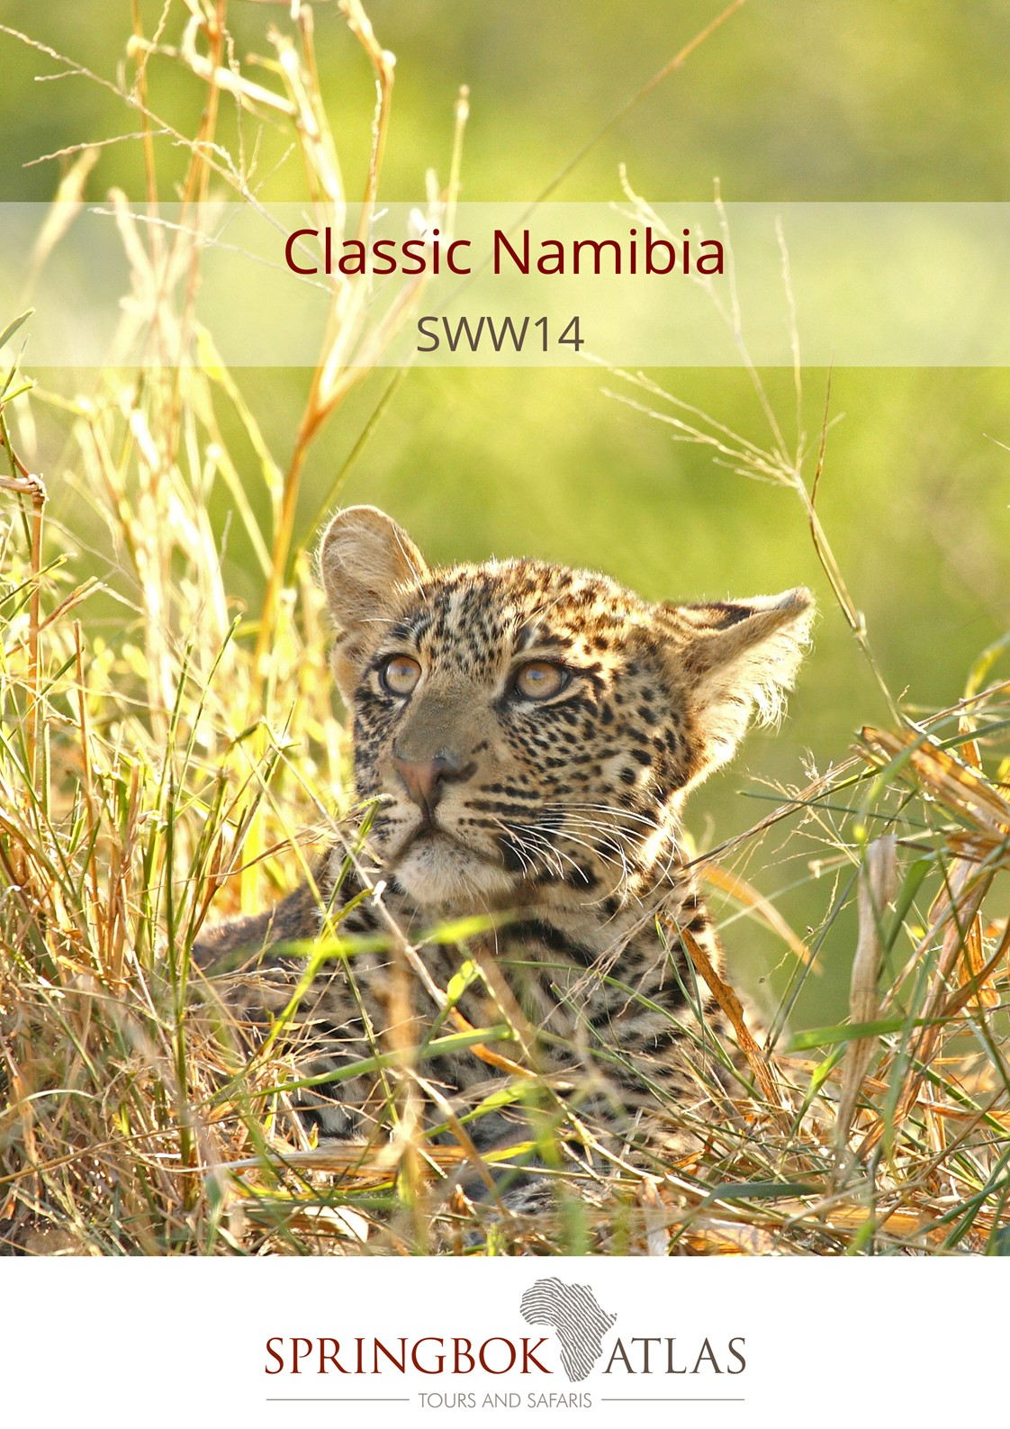

ITINERARY AT A GLANCE
DATE | ROUTING
DAY 1 - Monday | WINDHOEK – KALAHARI DESERT
DAY 2 - Tuesday | KALAHARI DESERT – FISH RIVER CANYON
DAY 3 - Wednesday | FISH RIVER CANYON – AUS
DAY 4 - Thursday | AUS – MALTAHOHE
DAY 5 - Friday | MALTAHOHE – NAMIB NAUKLUFT PARK
DAY 6 - Saturday | NAMIB NAUKLUFT PARK – SWAKOPMUND
DAY 7 - Sunday | SWAKOPMUND (UNGUIDED)
DAY 8 - Monday | SWAKOPMUND (UNGUIDED)
DAY 9 - Tuesday | SWAKOPMUND – DAMARALAND
DAY 10 - Wednesday | DAMARALAND
DAY 11 - Thursday | DAMARALAND – ETOSHA NATIONAL PARK
DAY 12 - Friday | ETOSHA NATIONAL PARK
DAY 13 - Saturday | ETOSHA NATIONAL PARK
DAY 14 - Sunday | ETOSHA NATIONAL PARK - WINDHOEK
 | END OF TOUR

Meal Key

BB Bed and Breakfast
DBB Dinner, Bed and Breakfast
DBB+ Dinner, Bed and Breakfast plus one additional activity
DBB++ Dinner, Bed and Breakfast plus two additional activities
FB Full Board (includes 3 meals per day)
FB+ Full Board (includes 3 meals per day) plus one additional service
FB++ Full Board (includes 3 meals per day) plus two additional services
FI Fully Inclusive (includes all meals and local drinks), plus all activities
LP Lunch Pack
BP Breakfast Pack

Minimum 2 guests / Maximum 12 guests

Selected departure dates

DURATION:

14 Days/13 Nights

ROUTING
WINDHOEK - WINDHOEK

DEPARTURE DATES
 | Nov17 | Dec17 | Jan18 | Feb18 | Mar18 | Apr18 | May18 | Jun18 | Jul18 | Aug18 | Sep18 | Oct18
Ger/Eng | 13 | 11 | 15 | 5;19 | 5;19 | 9;23 | 7;21 | 4;18 | 2;9;23;30 | 6;20;27 | 3;17 | 1;8;22

INCLUDES

13 breakfasts, 2 lunch (packs), 12 dinners, accommodation, bottled water on board, transport in air-conditioned vehicles, porterage, entrance fees and sightseeing as specified.

VISA REQUIREMENTS

Please check visa requirements, as certain nationalities may require visas in order to travel through Namibia

LANGUAGE
All departures are in dual language German/English commentary

Highlights: Kalahari Desert, Quiver Tree Forest, Fish River Canyon, Feral Horses of the Namib, Aus Mountains, Namib Desert and Sossusvlei, Moon Landscape, Swakopmund, Damaraland, Damara village, Etosha National Park

Rates valid 01/11/2017 - 31/10/18
NAD 49 500.00 per person sharing
NAD 54 100.00 per single person

Option to upgrade to Etosha Safari Lodge on Day 11 & 12 (subject to availability at the time of booking) at an additional cost of NAD 770.00 per person sharing / NAD 950.00 per single person

Accommodation used:
Kalahari Anib Lodge or similar x 1 night
Cañon Roadhouse or similar x 1 night
Klein Aus Vista - Desert Horse Inn or similar x 1 night
Hammerstein Rest Camp or similar x 1 night

Namib Naukluft Lodge or similar x 1 night
Brigadoon Guesthouse or similar x 3 nights
Twyfelfontein Lodge or similar x 2 nights
Etosha Safari Camp or similar x 2 nights
Mokuti Etosha Lodge or similar x 1 night

DAY 1 – MONDAY WINDHOEK – KALAHARI DESERT

Depart Windhoek and drive to the Kalahari Desert, via the small town of Rehoboth, a community that still lives according to their paternal laws dating back to 1872. The Kalahari Desert is not a desert in the strictest sense of the word, as it receives too much rainfall. It’s only the vast expanses of sand, through which precipitation filters rapidly, leaving nothing on the surface, that have made the Kalahari into the “thirst land” that early European settlers described. Enjoy a scenic, sunset nature drive in an open safari vehicle before dinner. [Dinner]
DAY 2 – TUESDAY KALAHARI DESERT – FISH RIVER CANYON

After breakfast, drive through the Kalahari region and visit the Quiver Tree Forest near Keetmanshoop. The forest was declared a national monument of Namibia and comprises of about 250 specimens of Aloe dichotoma, which the San people used to make quivers. A short stop will be made in Keetmanshoop, with lunch en route that will be for your own account. Visit the Naute Dam, Namibia’s third largest dam. Stretch your legs with an easy walk to a nearby mountain and enjoy a complimentary drink as you watch the sunset. [Breakfast & Dinner]

DAY 3 – WEDNESDAY FISH RIVER CANYON - AUS

This morning we travel to the spectacular Fish River Canyon, the largest canyon in Africa. It features a gigantic ravine, in total about 160km long, up to 27km wide and in some places 550m deep. Our journey continues to Aus with lunch en route (for own account). En route you might see the desert adapted Wild Horses of the Namib. These horses hold an irresistible fascination, as they managed to adapt to the harsh conditions of the desert. Enjoy spectacular scenery of the Aus Mountains on an unguided walk and a scenic sun downer drive in the afternoon (for own account). [Breakfast & Dinner]

DAY 4 – THURSDAY AUS - MALTAHÖHE

Today you’ll be spoilt with ever-changing vistas of the desert landscapes when driving along the most beautiful district road in Namibia, the D707 (road conditions permitting). Visit Duwiseb Castle, a grand medieval fortress, built in the hills of the semi-arid Southern Namib region. Learn more about the Castle’s fascinating history, before continuing to your lodge, arriving in the early afternoon. [Breakfast & Dinner]

DAY 5 – FRIDAY MALTAHÖHE – NAMIB NAUKLUFT PARK
Today will be an early start to explore the spectacular towering dunes of Sossusvlei and Dead Vlei, another pan where water once flowed, but all that remains today are the skeletons of trees that reach up out of the cracked earth. Enjoy a drive in 4x4 vehicles into the heart of the Namib Desert. Visit the rugged Sesriem Canyon where you can view millions of years of sedimentary layers in the ravine walls. Views from the top are breathtaking while walks through the canyon reveal distinct geographical layers which were laid down over centuries. Travel past the impressive Namib Naukluft Mountains to your lodge.

[Breakfast & Dinner]

DAY 6 – SATURDAY NAMIB NAUKLUFT PARK - SWAKOPMUND

After breakfast, drive through Kuiseb Canyon and continue towards Walvis Bay, Namibia’s largest commercial port. Enjoy an opportunity for lunch in Walvis Bay (for own account). The Walvis Bay Lagoon is considered one of the richest and most important wetlands in southern Africa, with prolific birdlife and diverse species. Our journey continues to Swakopmund, a city that resembles a small German town, with seaside promenades, restaurants, cafes and museums. Enjoy a sun downer drive to the Moon Landscape, a barren, undulating rocky desert which was formed by the valleys of the Swakop River. Enjoy a complimentary sun downer, whilst absorbing the rugged beauty of this lunar landscape. [Breakfast & Dinner]

DAY 7 - SUNDAY SWAKOPMUND (unguided)

Explore the quaint town of Swakopmund. You may wish to book an optional day tour (for own account) in Swakopmund (guided tour through the Mondesa township, quad-biking, sand-boarding; a scenic flight over the Skeleton coast or a catamaran cruise in Walvis Bay). Many optional activities are on offer (for own account): visit the aquarium, various museums or the crystal gallery. [Breakfast]

DAY 8 – MONDAY SWAKOPMUND (unguided)

Enjoy the splendours and many attractions of Swakopmund. There is a possibility of meeting fellow travellers at dinner that will be joining the tour in Swakopmund. [Breakfast & Dinner]

DAY 9 – TUESDAY SWAKOPMUND - DAMARALAND

Depart early morning and travel on the salt road towards Henties Bay, past salt pans and an array of bird life, to Damaraland, one of the most scenic areas in Namibia. Visit Twyfelfontein, a site of ancient rock engravings and the Organ Pipes, a distinctive series of dolerite pillars that have been exposed by erosion. Arrive at your lodge during the late afternoon. [Breakfast, Lunch pack & Dinner]
DAY 10 – WEDNESDAY DAMARALAND

The morning is at leisure, to relax at the lodge until lunchtime. In the afternoon, join a sun downer drive in the Aba Huab River and possibly encounter the desert dwelling elephants (seasonal). These elephants are not a distinct species but are African bush elephants that have made their homes in the Namib and Sahara deserts. They were once more widespread in Africa, but are currently found only in Namibia and Mali.[Breakfast, Lunch & Dinner]

DAY 11 – THURSDAY DAMARALAND – ETOSHA NATIONAL PARK

After breakfast, depart Damaraland and journey to the Etosha National Park. Visit a Damara village near Twyfelfontein and learn more about the culture and tradition of this half-nomadic people. Continue via the little town of Outjo. Lunch stop en route (lunch will be for own account) - possibly meet fellow guests joining the Etosha tour. From there continue to Etosha National Park. Arrive in the early afternoon and undertake your first game drive, in your closed touring vehicle, into the park. [Breakfast & Dinner]

DAY 12 – FRIDAY ETOSHA NATIONAL PARK

The morning will be spent in the Etosha National Park, exploring the waterholes along this enormous saltpan, in your closed touring vehicle. Return to the lodge for lunch (lunch for own account). There will be another opportunity in the afternoon for a game drive (in the closed touring vehicle) in the Etosha National park. There are close to 114 species of mammal in Etosha, including the black faced impala and the threatened black and white rhino. The Etosha Pan (a flat calcrete depression), contains water only after very good rains and sometimes only for a few days each year, but is enough to stimulate the growth of a blue green algae which lures thousands of flamingos. [Breakfast & Dinner]
DAY 13 – SATURDAY ETOSHA NATIONAL PARK

Enjoy a full day exploring this world famous National Park, in your closed touring vehicle. Your guide will introduce you to the complex subject of managing such an enormous reserve, that’s considered to be one of the world’s great wildlife sanctuaries. There will be an opportunity to buy a take away lunch at one of the rest camps inside the Etosha National Park (lunch for own account). [Breakfast & Dinner]
DAY 14 – SUNDAY ETOSHA NATIONAL PARK - WINDHOEK

After breakfast, travel south towards Otjiwarongo. Continue towards Windhoek via Okahandja where we will visit a local handicraft market. Tour ends on arrival in Windhoek late afternoon. [Breakfast]

STANDARD CONDITIONS OF BUSINESS

1 UNDERTAKING

Springbok Atlas undertakes to provide all services offered subject to the terms and conditions set out herein, which terms and conditions are accepted by the passenger.

2 DEFINITION

Springbok Atlas means: Cullinan Holdings (Pty) Ltd T/A Springbok Atlas Tours & Safaris

Passenger means: Individuals, groups, companies or other legal persons using the services offered by Springbok Atlas and includes the agents of passengers.

Services means: The provision of accommodations and/or transportation and/or meals as offered by Springbok Atlas and accepted by the Passenger.

3 TERMS OF PAYMENT

3.1 On confirmation of services - a deposit of 25 % of the quoted tour price is required (N.B. : For tours that include Blue Train and/or Private Game Reserves and Lodges, a different schedule of deposits, payments and cancellation fees apply. This will be provided when applicable.)
45 days before commencement of services - full payment plus rooming list is required.

Notes

i) Bookings made within 45 days of commencement of services must be accompanied by full payment of the tour plus rooming list.
ii) Where circumstances do not permit the timeous receipt of funds, explicit confirmation of transfer of funds will enable us to reserve services.

3.2 Payments may be deposited directly into the following bank account:

Springbok Atlas Pty Ltd
First National Bank of S.A. Ltd
Cape Town City Branch
Cape Town.

Account Number : 5462 676 2263
Bank Code : 201409
OR
Telegraphic Transfer
SWIFT CODE : FIRNZAJJ

3.3 If payments are made in negotiable foreign currency, the payer will be responsible for any short payment resulting from exchange rate fluctuations. The exchange rate applied by the official bankers of Springbok Atlas on receipt of moneys will be accepted as the applicable rate.

3.4 If the required deposit or final payment is not received by due date, Springbok Atlas reserves the right to withdraw services.

4 CANCELLATIONS

4.1 General Conditions

4.1.1 Cancellations made more than 45 days prior to arrival will not normally result in cancellation fees being charged. However;

4.1.2 Springbok Atlas reserves the right to recover any costs incurred or charges received from suppliers up to the date of cancellation.

4.1.3 In the event of services being cancelled 45 days or less, prior to arrival, the following cancellation fees will apply.

- 45 days to 36 days before commencement of services: 25% total quoted tour price due. (Subject to 2. above)
- 35 days to 16 days before commencement of services: 50% of total quoted tour price due. (Subject to 2. above)
- 15 days or less before commencement of services : 100% of the total quoted tour price due

We recommend that you ensure that your passengers take adequate personal cancellation insurance cover before departure from home.

4.2 Special Conditions

For tours that include services of certain suppliers with more stringent policies, e.g., National Parks Board, Blue Train, Private Lodges and others, different cancellation fees will be enforceable. These will be provided when applicable.

5 AIRLINES

Cancellations and refunds

In the event of cancellation or failure, for any reason whatsoever, to use confirmed space, as ticketed, 25% (twenty five percent) of the applicable airfare will be forfeited. A change of reservation constitutes a cancellation. Extension of ticket validity is no permitted, save when a passenger is hospitalised due to illness or in the event of death of a member of the passenger’s immediate family.

Responsibilities and booking conditions

All airfare reservations are arranged subject to the conditions imposed by the respective airline.

6 LUGGAGE

One suitcase and one overnight bag per person is allowed. Springbok Atlas accepts no responsibility for loss or damage to luggage or personal property from whatsoever cause arising. Passengers are advised to take up adequate insurance cover.

7 DELAYS

Springbok Atlas shall not be responsible for the consequences of any delays whether arising from accidents, breakdowns, or any other cause.

8 RESPONSIBILITY

Springbok Atlas carries comprehensive passenger liability insurance details of which will be made available on request. Springbok Atlas is not responsible for any damages sustained by any passenger as a result of any act or omission whatsoever of any hotel, airline or other person, notwithstanding the fact the Springbok Atlas acted as agent of such hotel, airline or other person.

9 LAW

The law of the Republic of South Africa shall govern the relationship between Springbok Atlas and the passenger and the Courts of the Republic of South Africa shall have sole jurisdiction in respect of any claims and/or disputes which may arise between Springbok Atlas and the passenger, or Agent.

